© The Author(s), under exclusive license to Springer Nature Singapore Pte Ltd. 2024
M. Kılıç, S. Bozkuş Kahyaoğlu (eds.), Algorithmic Discrimination and Ethical Perspective of Artificial Intelligence, Accounting, Finance, Sustainability, Governance S Fraud: Theory and Application
https://doi.org/10.1007/978-981-99-6327-0_1

The Interaction of Artificial Intelligence and Legal Regulations: Social and Economic Perspectives
Muharrem Kılıç¹ and Sezer Bozkuş Kahyaoğlu²
- Chairman of HREIT-Human Rights and Equality Institution of Türkiye, Ankara, Turkey
- Commercial Accounting Department, University of Johannesburg, Johannesburg, South Africa

Muharrem Kılıç
Email: muharrem.kilic@tihek.gov.tr
Sezer Bozkuş Kahyaoğlu (Corresponding author) Email: sezer.kahyaoglu@uj.ac.az
Email: sezer.bozkus@bakircay.edu.tr
Abstract
With artificial intelligence, a facilitating change expectation emerges not only at work but also at home and in all social environments including digital. This situation opens the discussion of artificial intelligence applications and the legal interaction with an ethical perspective regarding humanity, which concerns every environment, including public and private areas. This study aims to reveal the situations that may arise if the algorithms that form the basis of artificial intelligence applications are biased and what needs to be done to prevent this in relation to the Fair, Accountable, and Transparent (FAT) approach. Based on the fact that artificial intelligence has a wide

variety of dimensions, we try to contribute through its legal and economic perspectives.
Keywords Responsible artificial intelligence – Algorithmic discrimination – Ethics – Human rights – Algorithmic bias – Fair, accountable, and transparent (FAT) – Artificial intelligence systems
Muharrem Kılıç After completing his law studies at Marmara University Faculty of Law, Kılıç was appointed as an associate professor in 2006 and as a professor in 2011. Kılıç has held multiple academic and administrative positions such as Institution of Vocational Qualification Representative of the Sector Committee for Justice and Security, dean of the law school, vice-rector, head of the public law department, head of the division of philosophy and sociology of law department. He has worked as a professor, lecturer, and head of the department in the Department of Philosophy and Sociology of Law at Ankara Yıldırım Beyazıt University Faculty of Law. His academic interests are “philosophy and sociology of law, comparative law theory, legal methodology, and human rights law”. In line with his academic interest, he has scientific publications consisting of many books, articles, and translations, as well as papers presented in national and international congresses.
Among a selection of articles in Turkish, ‘The Institutionalization of Human Rights: National Human Rights Institutions’; ‘The Right to Reasoned Decisions: The Rationality of Judicial Decisions’; ‘Transhumanistic Representations of the Legal Mind and Onto-robotic Forms of Existence’; ‘The Political Economy of the Right to Food: The Right to Food in the Time of Pandemic’; ‘The Right to Education and Educational Policies in the Context of the Transformative Effect of Digital Education Technology in the Pandemic Period’ and ‘Socio- Politics of the Right to Housing: An Analysis in Terms of Social Rights Systematics’ are included. His book selections include ‘Social Rights in the Time of the Pandemic: The Socio-Legal Dynamics of Social Rights’ and ‘The Socio-Political Context of Legal Reason’. Among the English article selections, ‘Ethico-Juridical Dimension of Artificial Intelligence Application in the Combat to Covid-19 Pandemics’ and ‘Ethical-Juridical Inquiry Regarding the Effect of Artificial Intelligence Applications on

Legal Profession and Legal Practices’ are among the most recently published academic publications.
He worked as a Project Expert in the ‘Project to Support the Implementation and Reporting of the Human Rights Action Plan’, of which the Human Rights Department of the Ministry of Justice is the main beneficiary. He worked as a Project Expert in the ‘Technical Assistance Project for Increasing Ethical Awareness in Local Governments’. He worked as a Project Researcher in the ‘Human Rights Institution Research for Determination of Awareness and Tendency project.’ Kılıç has been awarded a TUBITAK Postdoctoral Research Fellowship with his project on ‘Political Illusionism: An Onto-political Analysis of Modern Human Rights Discourse.’ He was appointed as the Chairman of the Human Rights and Equality Institution of Turkey with the Presidential appointment decision numbered 2021/349 published in the Official Gazette on 14 July 2021. He currently serves as the Chairman of the Human Rights and Equality Institution of Turkey.

Sezer Bozkuş Kahyaoğlu Assoc. Prof.Sezer Bozkuş Kahyaoğlu graduated from Bosporus University and earned the degree B.Sc. in Management. Sezer had MA degree on Money Banking and Finance at Sheffield University and Certification in Retail Banking from Manchester Business School, both with a joint scholarship of British Council and Turkish Bankers Association. After finishing her doctoral studies, Sezer earned Ph.D. degree in Econometrics from Dokuz Eylul University in 2015. Sezer worked in finance sector in various positions of head office. Sezer worked in KPMG Risk Consulting Services as Senior Manager. Afterwards Sezer joined to Grant Thornton as founding partner of advisory services and worked there in Business Risk Services. Afterwards Dr. Sezer worked in SMM Technology and Risk Consulting as Partner responsible from ERP Risk Consulting. During this period Sezer was a lecturer at Istanbul Bilgi University at Accounting and Auditing Program and Ankara University Internal Control and Internal Audit Program. Sezer worked as Associate Professor at Izmir Bakircay University between October 2018 and March 2022. Her research interests mainly include Applied

Econometrics, Time Series Analysis, Financial Markets and Instruments, AI, Blockchain, Energy Markets, Corporate Governance, Risk Management, Fraud Accounting, Auditing, Ethics, Coaching, Mentoring and NLP. Sezer has various refereed articles, books, and research project experiences in her professional field. She was among the 15 leading women selected from the business world within the scope of the “Leading Women of Izmir Project” which was sponsored by the World Bank and organized in cooperation by Aegean Region Chamber of Industry (EBSO), Izmir Governor’s Office, and Metropolitan Municipality.

Introduction
Today, there is a significant increase in data as a result of the development of the data generation process on a global scale in every field and in every sector with high technology. When this situation is shaped by the competitive environment, the analysis of the said big data has become a basic need. Although there are many tools and techniques developed for this, they can all be defined as autonomous systems and Artificial Intelligence (AI) applications, even if they are at different maturity levels in general. While these innovations started the era of digitalization, they also brought new risks as well as opportunities. The value of big data is known all over the world and efforts are made for value-added creative approaches. However, this is not an easy value-creation process, on the contrary, it becomes a source of social concern due to increasing legal, social, and institutional risks (ARTICLE 19 2019). In this study, these risks, which tend to increase constantly, are discussed, and evaluations are made in the context of human rights, ethical principles, and sustainability issues in the social dimension, which is one of the key application areas of AI.

Algorithms and the Possibility of Algorithmic Bias

Algorithms have a key role in the functioning of processes based on AI applications (Danks and London 2017). Therefore, the possibility of algorithmic bias is emphasized, and concerns are expressed by revealing the risks in this regard. However, the discussions so far in this field appear within the framework of the different meanings and uses of the term “bias” and there is complete confusion. In the literature, it is sometimes used only as a descriptive term, and sometimes it is expressed as a negative term. These different and varied approaches can create confusion and hinder healthy debate about when and how to respond to algorithmic bias. It is a fact that there are real concerns about this situation that we should worry about. However, it is also important to note that many different topics are unhelpfully brought together under the heading of “algorithmic bias”. In this respect, it seems that public debates about algorithmic bias combine many different types, sources, and impacts of these biases (Kirkpatrick 2016).
It is accepted that the word “bias”, which we take as a starting point, has a negative connotation in the English language. Jackson (2021) defines an algorithm as “a set of instructions or rules designed to perform a specific task, duty, or goal allowing computers, smartphones, websites, and the like to function and make desired decisions…”. In fact, bias emerges as a situation that should be avoided, and this situation is of course also problematic because it affects the decision-making quality (PwC 2021). On the other hand, we understand this term
differently if we need to examine it more objectively: “bias” refers to the situation of deviation from a certain standard. This divergence can occur in a variety of ways, especially when describing statistical bias in which an estimate made in different domains deviates from a statistical standard. For example, “moral bias”, such as deviation from true population value, or where a judgment deviates from a moral norm, and similarly for regulatory or “legal bias”, “social bias”, “psychological bias”, and many others. From this point of view, if we make a generalization, we may encounter very different types of bias depending on the type of standard we used. The most important consequence to note here is that while the same thing may be viewed as biased by one standard, it may not be so by another (Danks and London 2017).

These different biases we mentioned for algorithms can originate from many different sources. Therefore, through this work, we try to contribute to society and science and raise awareness about resolving different situations where an algorithm may become biased. Thus, we aim to provide a richer domain for assessing whether a particular bias deserves a response and, if so, what corrective or mitigation measures can be implemented. The areas where algorithmic bias is encountered in practice can be at every stage of the process as shown in Fig. 1.1 (Kroll et al. 2016).
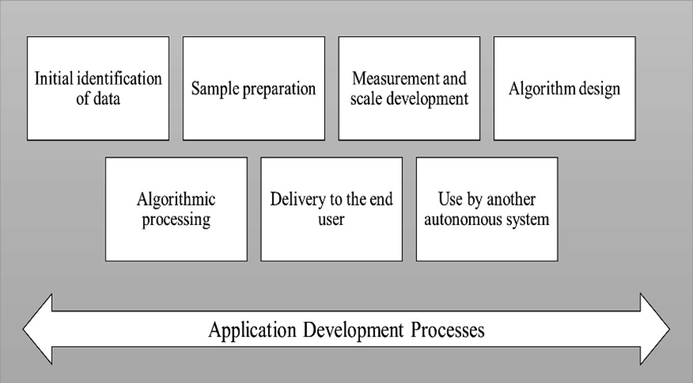
Fig. 1.1 The AI application development process open to algorithmic bias.
Source Adapted from Kroll et al. (2016)

This means awareness of how to respond to this issue in application development processes, from initial identification of data, sample preparation, measurement and scale development, algorithm design, algorithmic processing, delivery to the end user, or use by another autonomous system. Each independent entry point in the process of algorithmic bias provides the environment for analyzing a different set of problem-solving approaches, mindsets, and possibilities (Jackson 2021).

According to market research¹ conducted by PwC (2021), top managers think that measures should be taken to eliminate algorithmic bias. This idea is important in terms of developing responsible AI practices and highlighting the ethical dimension more. Top managers declared that this issue is among the top three among their corporate strategies in 2021 (Fig. 1.2).
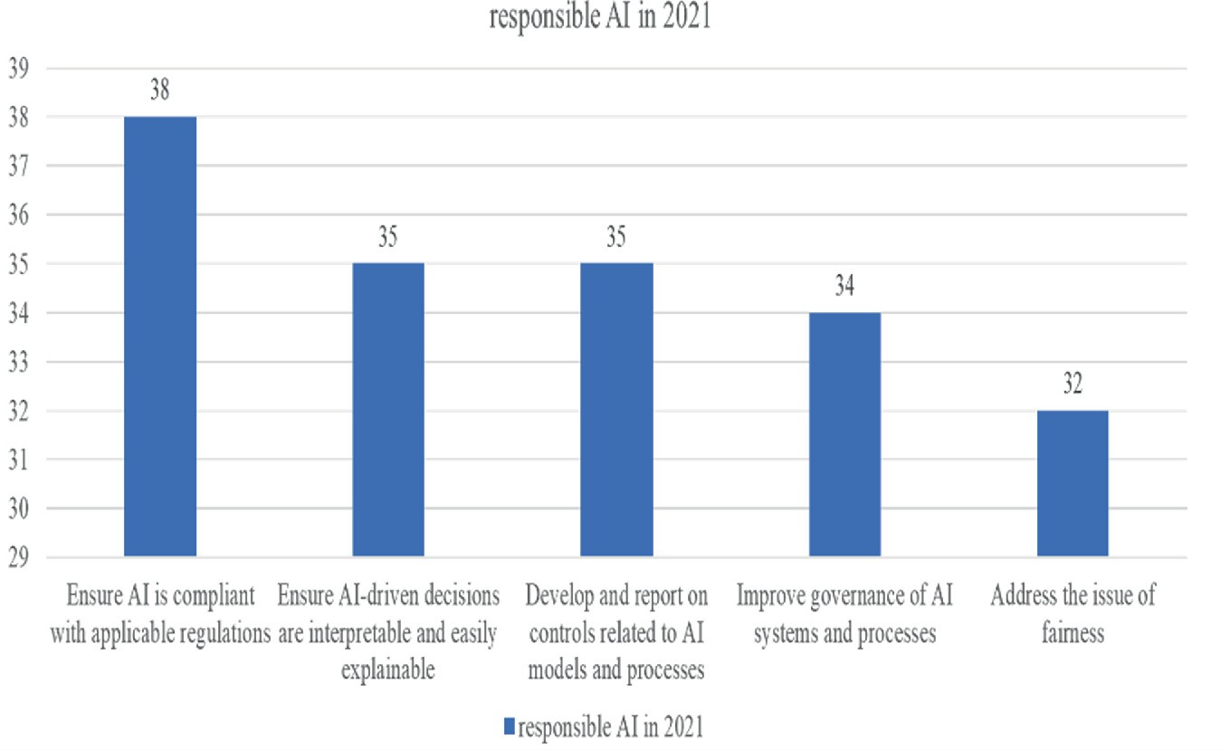
Fig. 1.2 Mitigating bias and creating responsible AI in 2021.
Source PwC (2021)

As a summary of these considerations, detailed in Fig. 1.2, intelligent algorithms are needed for responsible AI (PwC 2021; Jackson 2021). This study aims to contribute to raising awareness of responsible AI applications. Especially the international community should build consensus and analyze in-depth how AI technologies violate human rights in different contexts. In particular, new approaches should be developed in order to result in effective legal solutions in emerging problem areas.
It may be a mistake to limit the subject only to ethical principles (Saslow Kate and Lorenz 2017). Instead, it is important to focus on human rights by keeping our perspective wider than ethical principles.

ARTICLE 19 (2019) argues that ethical principles remain weak within the scope of accountability and therefore will be insufficient to develop a responsible approach to AI applications. It emphasizes human rights as a solution to this. Particularly to have more accountability measures that can be taken and more liability can be provided for state and private sectors to implement responsible AI.

AI Systems with Fair, Accountable, and Transparent Perspective
The widespread use of AI systems in society day by day gives rise to concerns about discrimination, injustice, and exercise of rights, among others. There is a global scientific community that takes initiative in this regard and is working to address these issues by developing fair, accountable, and transparent (FAT) AI systems. This community aims to analyze many influencing factors, especially ethics, in order to expand an AI field of study based on the FAT perspective (ARTICLE 19 2019).
We prepared this book to deal with the key issues mentioned here in detail and to contribute to the relevant literature. The issue of prohibition of discrimination is discussed comprehensively with its legal and social dimensions. The concept of non-discrimination, which emerged in AI applications, is examined from a socio-political perspective. The rapid spread of AI applications as a result of digitalization also brings some social problems, especially in the judicial sector. Therefore, the “digital surveillance” or “meta- surveillance” mechanism and the responsible use of intelligent algorithms in the virtual environment are presented as a discussion platform for rethinking non-discrimination law in the age of AI (Borgesius 2018). In this context, the legal practices of different countries are evaluated by emphasizing the current situation and future expectations regarding the legal regulations regarding the prohibition of discrimination, which has become a strategic area in the age of AI. While we propose solutions to the problematic areas encountered in this field, we specifically state what needs to be done to design a successful contestation mechanism based on relevant

literature. Accordingly, it is reminded that attention should be paid not only to the contestation itself or the structure of the algorithm alone but also to the underlying legal framework as well as the entire decision-making system, i.e., human, machine, and organizational mechanisms (Xiong et al. 2022). It should be noted that mitigating the violation of human rights, especially non-discrimination is important. In this respect, it is recommended to establish compliant mechanisms by comprising ex ante and ex post periods.
There is a need for regulating AI against discrimination. This issue should be discussed in a broad perspective starting from Data Protection Legislation to AI-Specific Measures. Depending on the concept of data protection, it generally accepts the right to protection of personal data as a fundamental human right. In this context, it imposes certain legal obligations on persons who have access to personal data to prevent the use of such data without the knowledge of the person concerned, and in some cases even without his or her consent. The most important risk emphasized here is the risk of being discriminated against during the processing of personal data by automated decision- making (ADM) systems. ADM systems are generally developed based on AI and machine learning technologies. Data of natural persons can be fed into the system to train the model used during the development of these applications. Therefore, personal data of natural persons is the basis for the decisions of ADM systems (Hofmann 2021).
Because of the rapid spread of AI applications, the new environment and problematic areas created by algorithms are evaluated. In particular, it is discussed whether the “right to disclosure” regulation in GDPR, which has significant effects in the legal sector and entered into force in the EU on April 25, 2018, can be used as a remedy to solve these problems. The problems of the social and legal environment in the digitalized should be assessed considering the new world order. In this context, it opens to discuss the level of sufficiency of fighting with the current criminal law rules regarding the use of AI from society’s perspective. Based on the rapid spread of AI applications, it should be examined how responsibility can be handled in terms of criminal law in cases where the decisions taken constitute a crime.
First of all, it may come to mind that there is a criminal liability for the AI itself. However, some controversial issues should be noted. First,

it is controversial that AI, which does not form legal personality, is held liable in terms of criminal law. Secondly, the responsibility of the software developer, which is important for AI applications and creating their algorithms. However, in this second case, there is a difference between the willful or negligent responsibility of the software developer, and this should be examined separately. In terms of the negligent responsibility of the software developer who created the AI algorithm, it is evaluated whether the issue of whether AI can be used in crime is predictable. Thus, in cases where an AI algorithm is used in the commission of a crime, it should be examined whether the existing regulations are sufficient in determining the responsibility in terms of criminal law.
Today, AI-oriented regulations are becoming more and more common in the field of law. In this context, predictive policing practices used in detecting and preventing possible crimes are gaining importance. In predictive policing practices, there are algorithms based on data about crimes committed in the past (such as the location and time of crimes, perpetrator, and victim) and a risk assessment and analysis regarding the commission of a new crime. The increase in the number of criminal data reveals a new trend in the prevention of crime and criminal activities before it occurs, with studies based on these data. When evaluated from this point of view, a security architecture emerges that emphasizes foresight within the framework of future studies by examining the data. In this respect, AI-oriented regulations are becoming widespread every day (Council of Europe 2019; Hofmann 2021).
As a result of this risk analysis, the police take the necessary measures to prevent crime. At first glance, the use of AI in predictive policing gives the impression that risk assessment and its consequences are independent of human bias. On the contrary, AI algorithms have the potential to contain all the biases of the people who designed the algorithms in question. In addition, the data analyzed based on algorithms are not free from prejudices and inequalities of societies. Therefore, predictive policing practices are likely to reflect the discriminatory thinking and practices of both individuals and societies. To prevent this situation, predictive policing practices are critically examined, and possible solutions are discussed in the further sections.

In this study, the discriminatory side of predictive policing practices is revealed and, in this way, steps that can be taken to protect minorities and vulnerable groups in society are evaluated (McDaniel and Pease 2021).
Considering the criteria used in the software process with algorithmic bias in AI applications, it is highly likely to cause discrimination in legal aspects such as punishment, justice, and equality. Especially, in the process of using AI technologies by law enforcement, there are some basic problems that these discriminations can cause. These fundamental problems can be presented as cases that lead to discrimination and prejudice. In this framework, it is necessary to examine the fundamental issues surrounding fair trial rights related to transparency, accountability, and AI applications (Deloitte 2019). At this point, it can be stated that the need arising from the continuous updates that arise due to the progress and development of technologies should create a general framework in a way that covers the legal basis of the subjects in general and the time domain.
In particular, it is important for the sustainability of positive developments and improvements achieved through AI technologies. Because when used correctly and legally, AI technologies are extremely beneficial and efficient for both individuals and societies.
Discrimination can be expressed as the product of a decision- making mechanism using AI systems. Therefore, some legal problems may arise specific to such situations. Here is an example of these problems. It is a fact that the results produced by some AI technologies cannot be fully explained. However, in order to conclude that a decision is based on discrimination from a legal point of view, it is first necessary to know the reasons on which this decision is based.
Considering the existing legal liability rules, those who develop and update the AI system cannot be held directly responsible to the victim of discrimination. It is necessary to produce a suitable solution to the problems in this regard. In this context, the general approach to be adopted by the legislators in the future related to the liability rules for the damages caused by AI will be decisive.
The interaction of law and AI is due to the fact that legal regulations and legal are the general rules that regulate every stage and stage of life. In this context, in every sector where AI is applied, AI legal

interaction emerges depending on the legal regulations specific to that sector. This interaction reveals the necessity of addressing the application in each sector with its own scope and framework within the framework of AI law interaction. In general, it is seen that AI applications, which are evaluated within the framework of criminal law and public law, are subjects that need to be examined from a private law perspective, considering the sectors. In this context, discrimination, and the state of being a new product caused by the use of AI systems to this discrimination; emerges as a legal issue.
In practice, it is debatable whether the developers and updaters of AI systems have legal responsibility for the victims of discrimination. When evaluated from this point of view, it is necessary to produce a solution for this as well and to reveal information in decision-making.
In terms of the literature, it is seen that there are legal gaps regarding the damages caused by AI. More importantly, the information regarding the determination of responsibility and the punishment to be taken against it in the field of private law is still not fully revealed. In terms of country practices, the subject necessitates an important doctrinal discussion within the Anglo-Saxon and continental European legal systems. The emergence of technological advances mostly in countries with an Anglo-Saxon legal system causes these rules to be determined depending on the structure of the legal system in question. The process will initiate a transformation within the framework of the continental European legal system, as well as a new development depending on the harmonization efforts of the institutions that make up the legal rule (Atabekov 2023; Dixon 2022).
The most important field of change brought about by the development of AI is the discussion of the legal characteristics of robots that will provide the most important convenience in people’s lives. In particular, the personality of the decision-making systems in matters that may affect people’s lives, what the effects of those who develop these systems can be in the legal problems that arise, whether all possible factors are taken into account in the decision-making processes, reveal a wide range of information that can be considered as an important topic of discussion. From this point of view, the most important problem that robots and high technology will create if we

call it automation in short, will have an impact on the employment structure of digital transformation in labor markets (Bavitz et al. 2019).
Today, it is seen that algorithm-based AI systems are used in the management of the process, including the recruitment process, to measure employee performance in human resources. Accordingly, it becomes controversial whether these systems produce an equal and fair result, especially ethical, by taking into account all corporate governance standards, elements, and criteria. In this sense, with AI technology, the necessity of considering the criteria and criteria of social rights emerges. At this point, the need for new jurisprudence to be formed in order to harmonize the previous court decisions with today’s conditions is increasing. The interaction of AI and law, which is generally considered in the context of developments in the digital field, showed itself with the regulations aimed at preventing discrimination and hate speech on platforms such as Twitter, Instagram, Facebook, YouTube, and TikTok. The detection of this discrimination and hate speech is mainly based on AI methods, and techniques such as artificial neural networks, support vector machine algorithms, and decision trees are used in this framework. However, when the criteria of discrimination and hatred on the basis of discourse change over time, the adaptation and adaptation of these tools and the time difference that may arise between them may cause delays in implementation (Alarie et al. 2018). In this sense, it is necessary to take into account the effects of techniques aimed at reducing discrimination and hate speech, which may increase productivity by increasing the acceleration in other fields and applications, and also save time, together with measures to eliminate the aforementioned problems in digital environments (Cartolovni et al. 2022).
We can state that AI applications have the potential to initiate an important growth trend through positive internal and external economies, where economies of scale and economies of space are intertwined in economic terms. In this sense, it can be said that any AI application can create in another sector with another knowledge created by more than the size of the effect it has created in one sector.
In this context, the expectation of humanity about AI applications is formed according to the expectations, depending on the effects of these applications in the health sector and the quality of health services.

Considering that climate change has become an important health problem in today’s conditions, it can be stated that AI can initiate a great change in this field. It can be stated that collecting all information on the same platform, especially in health business processes, can reveal a new understanding of health through natural language processing methods and AI applications.
Especially, in the age of communication, the emergence of a global exchange of information in the field of medicine, while smart tools and robotic applications accelerate decision-making in diagnosis, it also enables many applications to be carried out remotely. The main problem here is the inadequacy of regulations against legal problems that may be caused by not fully determining the applications with algorithm-based criteria, despite the potential of AI applications to improve and reduce human error (Bavitz et al. 2019).

Concluding Remarks and Future Expectations
The legal dimension of AI applications in economic and social terms has a contrast and symmetry feature in itself. The contrast will be valid in practice with the rules and regulations based on the new algorithm and AI applications that will emerge as a result of teaching the rules and regulations to AI algorithms. In this case, the validity of the algorithmic bias and its outputs brings with it a discussion in itself.
The most important issue that we may encounter in terms of social and economic aspects, is whether the tools that learn, make decisions, and produce the decisions that have effects in the end, gain legal personality and the problem of legal penalties and also the sanctions against the negative results that arise here should be opened up for discussion.
The most important problem is that by teaching social and public knowledge to existing algorithms and AI systems, it becomes controversial who will have the power to determine how effective this will be in decision-making. Based on these principles, we come across the necessity of dealing with AI regulations with different dimensions from the current social development level and economic perspective.

However, when evaluated with its self-feeding tendency, which creates positive social effects together with the spread effects, as mentioned before, a new architecture will emerge where scientists from various fields will come together to discuss future expectations.

References
Article 19 (2019) Governance with teeth: how human rights can strengthen FAT and ethics initiatives on artificial intelligence. https://www.article19.org/wp-content/uploads/2019/04/ Governance-with-teeth_A19_April_2019.pdf. Accessed 09 May 2022
Alarie B, Niblett A, Yoon AH (2018) How artificial intelligence will affect the practice of law. Univ Tor Law J 68:106–24. https://tspace.library.utoronto.ca/bitstream/1807/88092/1/ Alarie%20Artificial%20Intelligence.pdf. Accessed 01 Mar 2023
Atabekov A (2023) Artificial intelligence in contemporary societies: legal status and definition, implementation in public sector across various countries. Soc Sci 12:178. https://doi.org/10. 3390/socsci12030178
[Crossref]
Bavitz C, Holland A, Nishi A (2019) Ethics and governance of AI and robotics. https://cyber. harvard.edu/sites/default/files/2021-02/SIENNA%20US%20report_4-4_FINAL2.pdf. Accessed 1 Mar 2023
Borgesius FZ (2018) Discrimination, artificial intelligence, and algorithmic decision-making. Council of Europe-Directorate General of Democracy. https://rm.coe.int/discrimination- artificial-intelligence-and-algorithmic-decision-making/1680925d73. Accessed 09 May 2022
Cartolovni A, Tomicic A, Mosler EL (2022) Ethical, legal, and social considerations of AI-based medical decision-support tools: a scoping review. Int J Med Inform 161:104738
Council of Europe (2019) artificial intelligence and data protection. Adopted by the committee of the convention for the protection of individuals with regards to processing of personal data (Convention 108) on 25 January 2019. https://rm.coe.int/2018-lignes-directrices-sur-l-
intelligence-artificielle-et-la-protecti/168098e1b7. Accessed 09 May 2022
Danks D, London AJ (2017) Algorithmic bias in autonomous systems. In: Paper presented at the proceedings of the 26th international joint conference on artificial intelligence. https://www. ijcai.org/proceedings/2017/654
Deloitte (2019) Transparency and responsibility in artificial intelligence. https://www2. deloitte.com/content/dam/Deloitte/nl/Documents/innovatie/deloitte-nl-innovation-bringing- transparency-and-ethics-into-ai.pdf. Accessed 09 May 2022
Dixon RBL (2022) Artificial intelligence governance: a comparative analysis of China, the European Union, and the United States. University of Minnesota Digital Conservancy. https:// hdl.handle.net/11299/229505

Hofmann HCH (2021) An introduction to automated decision-making (ADM) and cyber- delegation in the scope of EU public law (June 23, 2021). University of Luxembourg Law Research Paper No. 2021-008, SSRN: https://ssrn.com/abstract=3876059 or https://doi.org/ 10.2139/ssrn.3876059. Accessed 10 May 2023
Jackson MC (2021) Artificial intelligence S algorithmic bias: the issues with technology reflecting history S humans. J Bus Tech L 16:299 (2021). https://digitalcommons.law. umaryland.edu/jbtl/vol16/iss2/5. Accessed 09 May 2022
Kirkpatrick K (2016) Battling algorithmic bias. Commun ACM 59(10):16–17 [Crossref]
Kroll JA, Huey J, Barocas S, Barocas S, Felten EW, Reidenberg JR, Robinson DG, Robinson DG, Yu H, Accountable Algorithms (2016) University of Pennsylvania law review, vol 165, 2017 Forthcoming, Fordham Law Legal Studies Research Paper No. 2765268, SSRN: https://ssrn. com/abstract=2765268. Accessed 09 May 2022
McDaniel J, Pease K (2021). Predictive policing and artificial intelligence. Routledge Publications. ISBN 9780367701369
PwC (2021) Understanding algorithmic bias and how to build trust in AI. https://www.pwc. com/us/en/tech-effect/ai-analytics/algorithmic-bias-and-trust-in-ai.html. Accessed 09 May 2022
Saslow Kate K, Lorenz P (2017) Artificial intelligence needs human rights: how the focus on ethical AI fails to address privacy. Discrimination and Other Concerns
Xiong W, Fan H, Ma L, Wang C (2022) Challenges of human–machine collaboration in risky decision-making. Front Eng Manag 9(1):89–103 (2022). https://doi.org/10.1007/s42524-021- 0182-0. Accessed 09 May 2022

Footnotes
1 Q: What steps, if any, will your company take in 2021 to develop and deploy AI systems that
are responsible, that is, trustworthy, fair, bias-reduced and stable? Form list of 10 choices. Source: PwC (2021) AI Predictions. Base: 1,032.

OceanofPDF.com

